SPS photocells
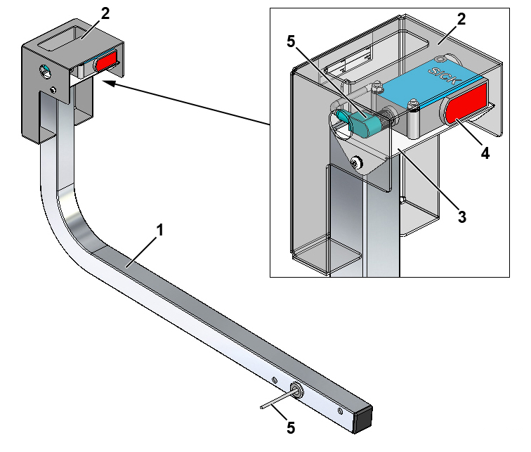
Fig. 1-1 Complete SPS photocell, right
1. | Support
2. | Photocell housing, vertically adjustable
3. | Mounting bracket for photocell, adjustable
4. | Photocell, diffuse-reflective
5. | Photocell cable

Preparation necessary
The sorter frame must be installed and the train of carts put in place before SPS photocells can be fitted. Cabinets for I/O modules must also have been installed before photocells can be connected. If the SPS photocells are to be installed on loose frames, the loose frames must be mounted on the sorter frame before the SPS photocells are fitted.

Tools
Supplied Customer Tool Kit CB 4000

Guides
- Electrical component location drawing
- Wiring diagram for SPS
- I/O lists

Installation guide
The SPS photocells can be mounted on either one of the section’s fixed frames or a loose frame, depending on where it is to be located.

Fitting a loose frame
.1 Assemble a loose frame as shown in Fig. 1-2 without tightening the screws and extend the two halves into extreme position.
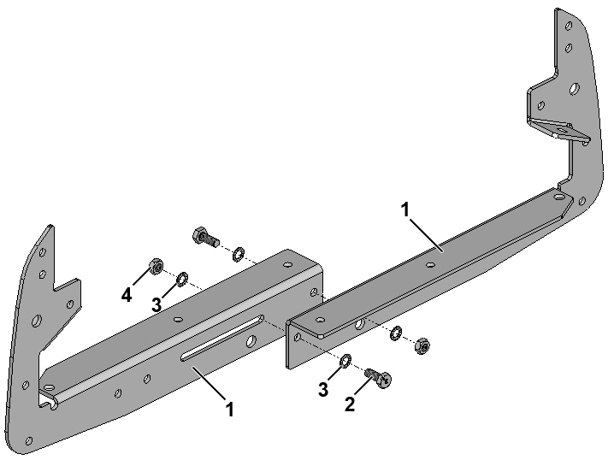
Fig. 1-2 Assembly of loose frame for section
1. | Loose frame for section, half
2. | Set screw
3. | Lock washer
4. | Nut

.2 Position the loose frame on the section as shown in Fig. 1-3.
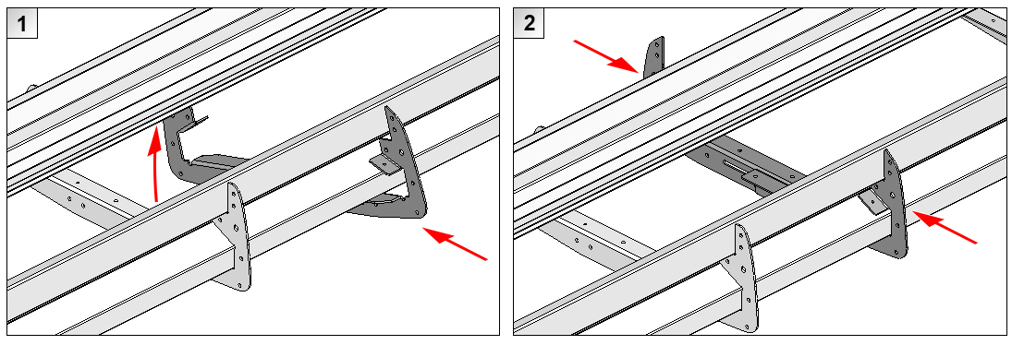
Fig. 1-3 Mounting loose frame on section
.3 Move the loose frame forward or back in the sorter section’s longitudinal direction until its position corresponds to the location specified for SPS in the electrical component location drawing.
.4 Secure the frame to the section as shown in Fig. 1-4.
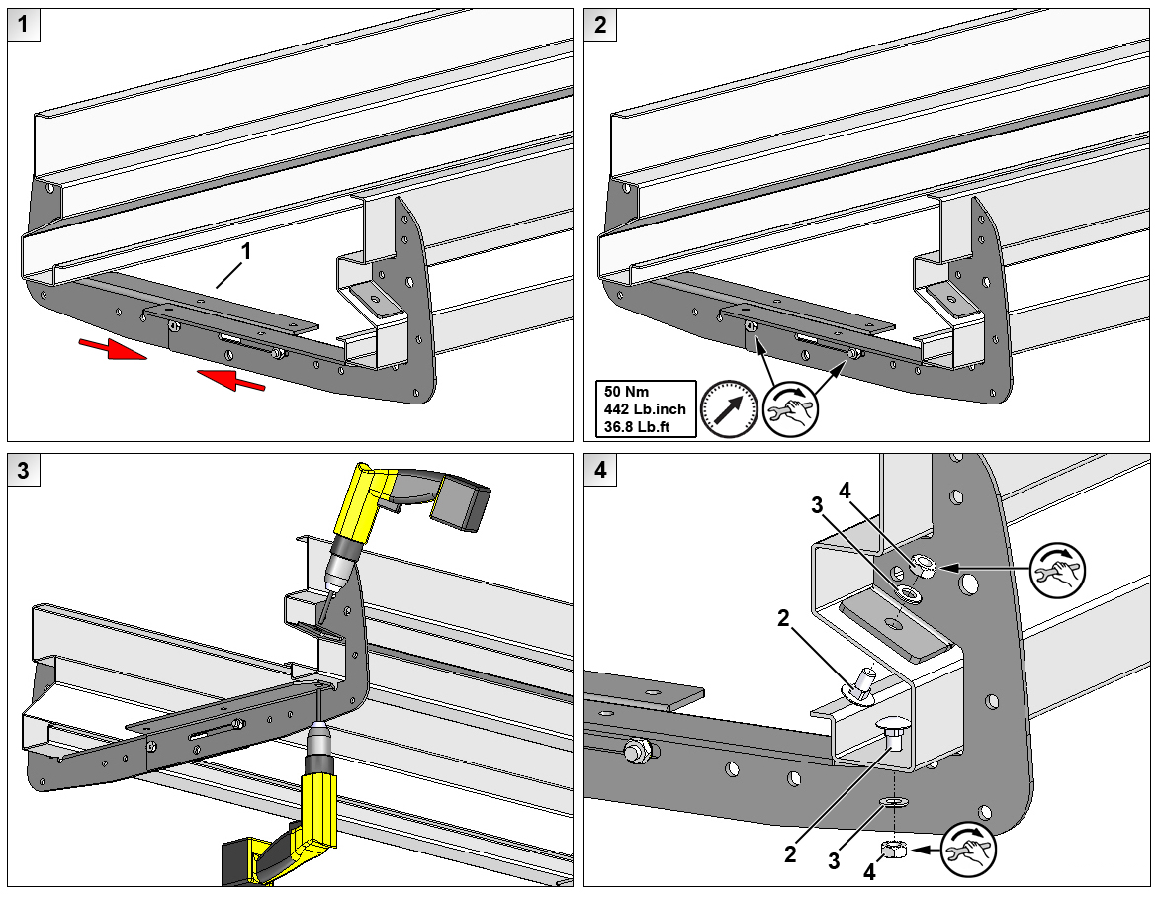
Fig. 1-4 Securing loose frame to section
1. | Loose frame for section | 3. | Washer, 10 mm
2. | Carriage bolt, M10x20 mm | 4. | Nut, M10

Installation of SPS photocells
.1 Mount the right-hand SPS photocell on the back of the frame on the right-hand side of the sorter frame as seen in the direction of travel.
.2 Mount the left-hand SPS photocell on the back of the frame on the left-hand side of the sorter frame as seen in the direction of travel.
.3 Secure the supports with SPS photocells to the frame as shown in Fig. 1-5.
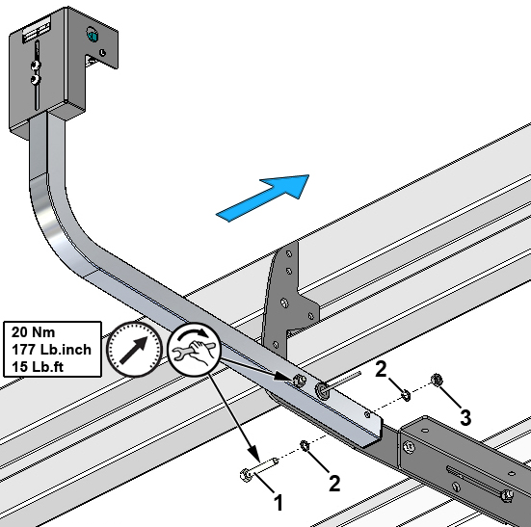
Fig. 1-5 Securing support with SPS photocell
1. | Hexagon bolt
2. | Lock washer
3. | Nut

.4 Run the photocell cables in the sorter frame’s left-hand cable tray – as seen in the direction of travel – to the cabinet for I/O modules.

 | If necessary, use an extension cable (part no. 419B841.L).

If necessary, use a cable exit (part no. 470B600) to run the photocell cables into the sorter. See the chapter entitled “Cabling components”.

.5 Connect the photocell cables in accordance with the I/O list.

Adjustment of SPS photocells
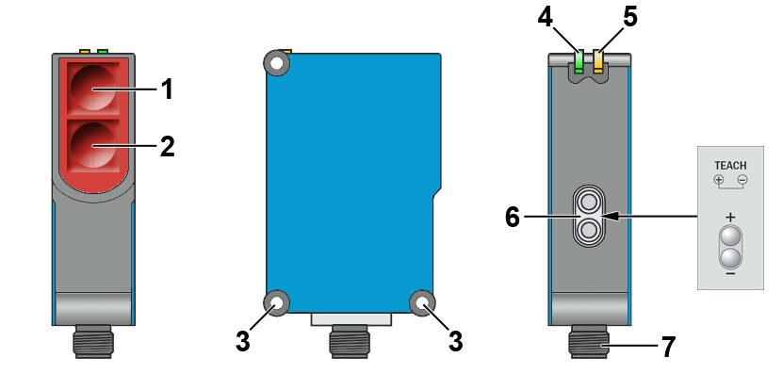
Fig. 1-6 Diffuse-reflective photocell, SICK WTB27-3P2413S09
1. | Transmitter | 4. | LED indicator, green; supply connected
2. | Receiver | 5. | LED indicator, yellow; status of received light
3. | Mounting holes Ø 5.2 mm | 6. | Adjustment of sensing distance “+” / “-“ (Teach)
 |  | 7. | M12 connector for photocell cable

.1 Position a cart with cross-belt unit next to the SPS photocell.
.2 Connect operating voltage to the photocell and check that the green LED lights up.
.3 Loosen the screws in the angle-adjustable mounting bracket so that the angle of the photocell can be adjusted in the vertical plane. See Fig. 1-7.
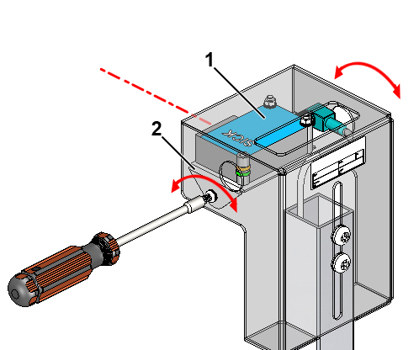
Fig. 1-7 Angle adjustment of SPS photocell
1. | Retro-reflective photocell
2. | Angle-adjustable mounting bracket

.4 Adjust the mounting bracket until the optical axis of the photocell is roughly parallel to the surface of the cross-belt unit as shown in Fig. 1-8.
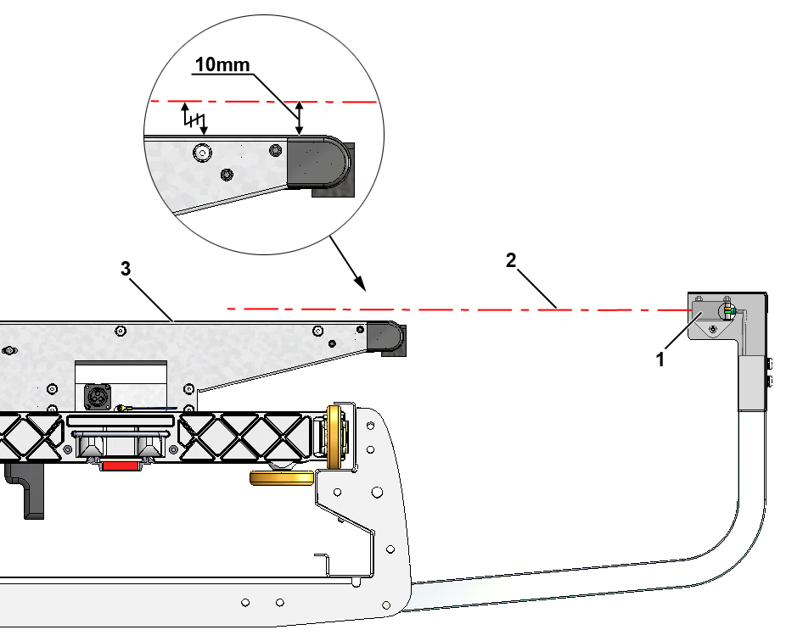
Fig. 1-8 Adjustment of sensing direction and sensing height
1. | SPS photocell
2. | Optical axis of photocell
3. | Cross-belt unit

.5 Tighten the screws in the angle-adjustable mounting bracket.
.6 Undo the screws securing the photocell housing to the support so that the height of the photocell can be adjusted. See Fig. 1-9.
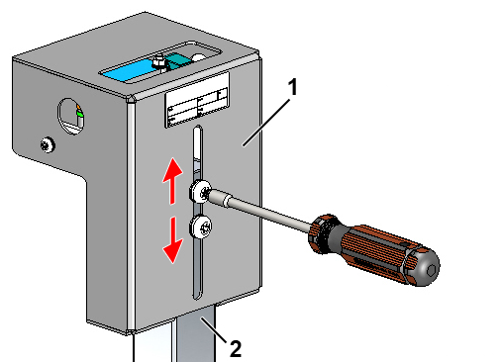
Fig. 1-9 Height adjustment of SPS photocell
1. | Photocell housing
2. | Support

.7 Move the photocell housing up or down until the optical axis of the photocell is approx. 10 mm above the surface of the cross-belt unit as shown in Fig. 1-8.
.8 Position an item with the minimum width stipulated in the item specification in the middle of the cross-belt unit next to the photocell as shown in Fig. 1-10.
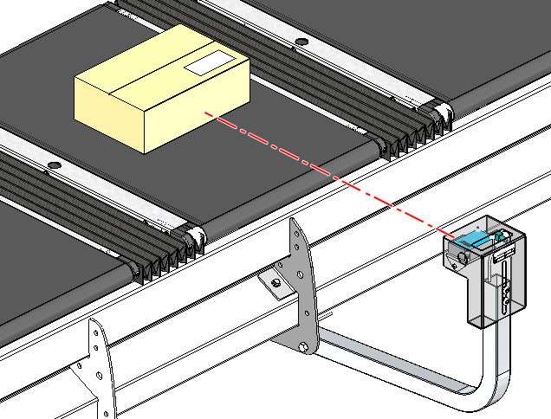
Fig. 1-10 Positioning of item with minimum width for adjusting sensing distance
.9 Adjust the sensing distance using the Teach buttons ("+" / "-"), see Fig. 1-6. The Teach buttons are on the back of the photocell and can be accessed via the hole in the surface of the photocell housing.
1. Press the "+" / "-" buttons simultaneously for approx. 2 seconds until the yellow receive lamp flashes. This means that the sensing object (minimum item) has been registered.
Teach-in will not work if the buttons are pressed for less than 2 seconds.
2. Release the "+" / "-" buttons. The yellow receive lamp will show a steady light and the sensing object has definitely been registered.
The photocell should now be set to detect any items that are taller than approx. 10 mm and of the same width as a minimum item.
.10 Run the sorter with empty cross-belt units and only the recently adjusted SPS photocell on. Check that the photocell is not obstructed by any of the empty cross-belt units.
.11 Then run the sorter with an item with minimum dimensions in the centre of one of the cross-belt units. Check that the photocell detects this item.
.12 Repeat the adjustment procedure for the opposite SPS photocell as described in points .1 - .11.

